A

Project Design Report on

## "Securing and Managing Patient Data of Rural Healthcare System Through Cloud Environment."

Submitted by

Mr. Sourabh S. patil

Mr. Sahil Y. Pathan

Mr. Vaibhav B. Chavan

Mr. Ajay S. Shete

Under The Guidance of

Prof. N. M. Sawant

For The Award of The Degree of Bachelor of Engineering



DEPARTMENT OF COMPUTER SCIENCE AND ENGINEERING

SKN SINHGAD COLLEGE OF ENGINEERING

## (PUNYASHLOKAHILYADEVIHOLKAR, SOLAPUR UNIVERSITY)

2020-2021

DEPARTMENT OF COMPUTER SCIENCE AND ENGINEERING

## SKN Sinhgad College of Engineering, Korti, Pandharpur.



__CERTIFICATE__

This is to certify that, the project design report entitled "Securing and Managing Patient Data of Rural Healthcare System Through Cloud Environment"

Submitted by

__Mr. Sourabh S. Patil__

__ Mr. Sahil S. Pathan__

__Mr. Vaibhav B. Chavan__

__Mr. Ajay S. Shete__

In the partial full fllment for the award of the Degree of Bachelor of Engineering

This Project design work is a record of student's own work carried out by them under my supervision and guidance during the academic year

__2020-2021__

Prof. N. M. Sawant

Project Guide

Prof. N. M. Sawant

Head of Department

ABSTRACT

Rural healthcare system in India is managing patient data in a traditional paper based system. Most of the rural hospitals in India are lacking in resources to maintain and manage the patient health data. As the world moves towards digitization, one of the key challenges in developing countries like India is in making the healthcare data accessible from rural to urban in digital form. Advancement in IT technology in healthcare sector has made it possible to maintain and manage the patient data in digital form in all levels of healthcare system. Cloud computing has emerged as a main in providing healthcare IT solution. Therefore, rural healthcare organizations should move towards building their own private cloud infrastructure which could be an excellent solution for the country’s needs to have improved healthcare in rural areas.

In private cloud, medical data is stored in databases in which some of the data in a medical database is sensitive in nature and access to this data should be limited to authorized persons. In this paper we propose a secure cloud architecture by building private cloud. To reduce the risk of the health information leakage and safeguard the health data, hash and the encryption operation are performed before transmitting to the cloud database. With this technique, path for a third party to obtain the sensitive information stored in the cloud is being blocked. Therefore the proposed framework provides better secured services to the users

CONTENTS

1. Introduction 5

Different levels of healthcare system 6

1. Related Work 7
2. Proposed Work 9
3. Methodology 10

Private cloud solution to manage patient data in rural healthcare system: ….……… 11

* 1. Supporting infrastructure for sustainability 13

Testing for sustainability of the system 13

Authorizaion model for proposed private cloud model 15

1. UML Diagrams 18
   1. Usecase Diagram 20
   2. Activity Diagram 21
   3. Sequence Diagrams: 22
2. System Requirements27
   1. Hardware Requirements 27
   2. Software Requirements 27

# List of Figures

Different levels of healthcare system 5

Open source methodology for managing patient data in rural healthcare system……………13

Access the private data remotely using port forwarding techniques 13

High availability architecture for rural healthcare system ..14

Authorization Model for healthcare system ..15

Types of Cloud environment .16

Service models available 20

Use Case Diagram .21

Activity Diagram .21

System Sequence Diagram .22

Chapter 1

Introduction

The world’s population is growing rapidly . Developed countries have been facing the trend of population aging, escalating costs, inconsistent provision of care, and a high burden of chronic diseases related to health behaviors. This situation makes healthcare management more and more important to all types of healthcare organizations. Health care is delivered mainly through Primary Healthcare Centre (PHC), Secondary Care Centre (SHC), and Tertiary Care Centre (THC). The different levels of healthcare system is depicted in Fig. 1. The primary healthcare centre deal with patients whose medical conditions can be managed

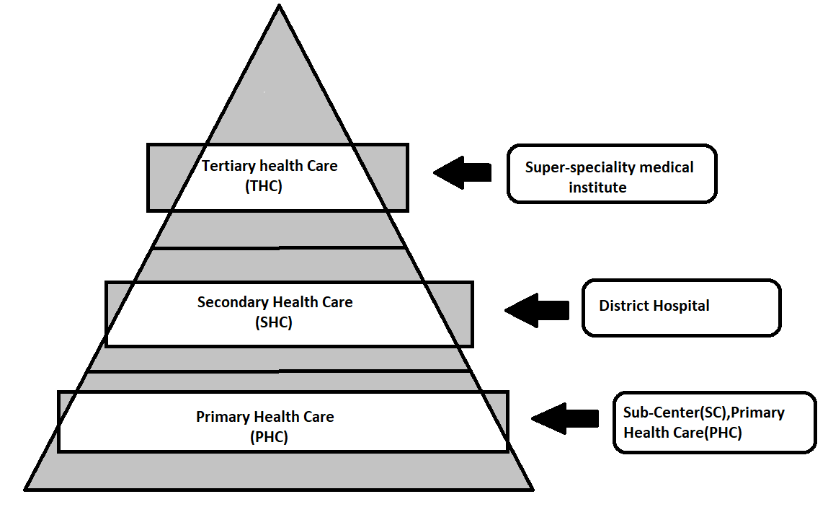

Fig. 1. Different Levels of health-care system

The secondary healthcare usually deals with acute care hospitals whereas tertiary care requires the resources of a sophisticated medical center. Healthcare ecosystem consists of physicians, nurse, pharmacist, radiologist, lab technician, and patient. Cloud computing helps in organizing the medical record at different levels of healthcare setting. Cloud computing is a promising and emerging technology for the users of the healthcare by connecting many health information management systems together with laboratory, pharmacy, radiology etc. The main obstacles and serious problem towards the rapid growth of cloud computing are data security and privacy issues. Most of the healthcare users of private cloud do not fully trust the inside threat of the healthcare organization for safeguarding sensitive health information4 data because there is no governance about how this information can be used by them and whether the healthcare organization actually control their information.

As part of the field study, hospitals at different healthcare levels namely Primary Healthcare Centre (PHC), Secondary Care Centre (SHC), and Tertiary Care Centre (THC) in Solapur district visited. Field study was conducted to understand the IT-infrastructure facility used for managing and maintaining the patient information. In this study it was observed that, in PHC levels, namely sub center, primary health center and. community healthcare center are maintaining yearly paper-based records such as registration book, examination book and treatment book. In the record room only current five years of patient data is maintained and previous ones are discarded. Because of this the continuous health data about the patient is lost. Hence present requirement for Indian healthcare scenario is to capture lifelong summary of the patient from pre-birth to post-death with better IT infrastructure facility. So in this project we are going to manage all data(Previoud one and new) of patient regarding health and medical

Chapter 2

Related Work

* Rui, Yong; Thomas S. Huang; Shih-Fu Chang (1999)[6] worked on past and current technical achievements in visual feature extraction, multidimensional indexing, and system design are reviewed. Open research issues are identi ed andfuture research directions sug- gested.
* Lin et al. [7] proposed work on a color-texture and color-histogram based image re- trieval system i.e, (CTCHIR). They proposed three image features, based on color, texture and color distribution, as color co-occurrence matrix (CCM), di erence between pixels of scan pattern (DBPSP) and color histogram for K-mean (CHKM) respectively and also used a method for image retrieval by integrating CCM, DBPSP and CHKM to enhance image detection rate and simplify computation of image retrieval. After this experiment they found in the result that their proposed method outperforms the Jhanwar et al. [8] and Hung and Dai [9] methods.
* Raghupathi et al.[10] have made a comparative study on image retrieval techniques, using di eren feature extraction methods like color histogram, Gabor Transform, color his- togram+gabour transform, Contourlet Transform and color histogram+contourlet trans- form.
* Hiremath and Pujari [11] also proposed work on CBIR system which is based on the color, texture and shape features by partitioning the image into tiles. The features com-

puted on tiles serve as local descriptors of color and texture features. The color and texture analysis are analyzed by using two level grid frameworks and the shape feature is used by using Gradient Vector Flow. The comparison of experimental result of proposed method with other system [12],[13] found that, their proposed retrieval system gives better perfor- mance than the others. Rao et al. [14] proposed CTDCIRS (color-texture and dominant color based image retrieval system), they integrated three features like Motif cooccurrence matrix (MCM) and di erence between pixels of scan pattern (DBPSP) which describes the texture features and dynamic dominant color (DDC) to extract color feature.

* Ritendra Datta, Dhiraj Joshi, Jia Li, James Z.[15] Wang in the Pennsylvania State University, University Park have worked with n this paper, they survey almost 300 key the- oretical and empirical contributions in the current decade related to image retrieval and automatic image annotation, and discuss the spawning of related sub- elds in the process. We also discuss signi cant challenges involved in the adaptation of existing image retrieval techniques to build systems that can be useful in the real-world. In retrospe "Image Re- trieval: Ideas, In uences, and Trends of the New Age" Fact of what has been achieved so far, we also conjecture what the future may hold for image retrieval research.

Chapter 3

Proposed Work

The efficient implementation of data management of patient through cloud environment will helps us to manage medical data of patient as well as availability of data at any time.

Chapter 4

Methodology

This section discusses about managing the patient data by building a private/public cloud with proposed security mechanism

**Private cloud solution to manage patient data in rural healthcare system:**

Fig. 4.1 shows the architecture of proposed model which describes one simple application of IaaS on private cloud using AWS. All the necessary setup was done and an instance was launched with the windows server 2016. Then by launching server instance using remote desktop connection , proper network settings like proxy settings, dns servers were configured and the internet connection was given to the instance.

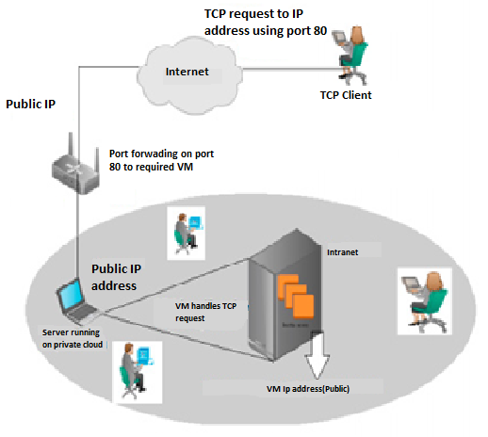

Figure 4.1: Open source methodology for managing patient data in rural healthcare system

it may be necessary to provide access to the private cloud from outside the intranet (Internet). Providing access means providing access to one or some of the VMs that are running on the private cloud. These VMs can be accessed using remote desktop connection(For Maintainance Purpose). Private cloud is mainly built for accessing the data from the intranet of the organization. The provision is given to the user to access the private data remotely using port forwarding techniques as shown in the Fig. 4.2. This concept was tested on the private cloud using a single public IP address. The server running the private cloud was connected to the INTERNET using a router. A VM was started on the cloud with a local intranet IP which had the public address assigned to it was configured to forward all requests on port 80 to the VMs local IP address. Now from the INTERNET, an TCP request was sent to the public IP address.

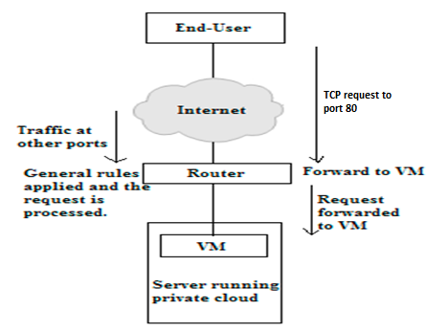

Figure 4.2: Access the private data remotely using port forwarding techniques

The request now reaches the VM which handles it and responds back to the IP address from which the request was generated. For providing access to multiple VMs. Apart from this, the private cloud was used to host a simple website as well by using port forwarding on port 80.

**Supporting infrastructure for sustainability :**

The proposed private cloud model ensures or supports high availability as shown in the Fig. 4.3. The model is durable and likely to operate continuously without failure for a long time. Also fault tolerance characteristics features allows to remain in operation even if some of the component used to build the system fail. Major building blocks of high availability architectures are healthcare user, load balancer, availability zone, snapshot and replication layer. The healthcare users are requesting health care services from the health information system and receiving response from the system. With load-balancer features, availability of the system increases by distributing the load between the zone. The request always move to the healthy running instances instead of going to the unavailability zone. It also automatically distributes the incoming application traffic among multiple instances using the load-balancing facility. Also load balancer is configured to handle encrypted (HTTPS) traffic, session persistence, health checking, and more.



Figure 4.3: High availability architecture for rural healthcare system

**Testing for sustainability of the system :**

The network connectivity is ensured by using the dedicated high speed optical networks, which connects all rural facilities including sub centre, primary health centre and community health centre. The private/Hybrid cloud services are created by using co-locating our server in Data Center(Institute TIER IV Certified).With this network connectivity is attained in all levels of healthcare system.

**Authorization model for proposed private cloud model :**

Authorization services include policy management, role management, and role-based access

control. Cloud based EHR(Electronic Health Record) for authorization as shown in Fig.4.4. Authorization model contains four rows for representing user (browser), application, Authorization server and resource server. User or browser own the resources which is stored in the remote server or remote database. If user wants to access the resources, first he/she has to enter the credentials such as user-name and password. User credential validation is done at the authorization server where after validation, it is redirected back to user for further access to the resources. On behalf of the user application, the token(Aadhar number) is obtained and returned to the application.Using this token, application talk to the resource server and get required data to access.The presentation page is displayed to the user to view the data.



Figure 4.4: Authorization Model for healthcare system

Algorithm :

1) Registration of doctors.

2) Verification of doctors by admin/authorized person.

3) Registration of patients via doctors.

4) Encryption and decryption of data (eg – credentials of doctors, Patient).

5) Managing all patient data (Insert, Update, Delete).

6) Doctor’s information management(Update, Delete).

Cloud computing is a broad term which refers to a collection of services that offer businesses a cost-effective solution to increase their IT capacity and functionality.

Depending on their specific requirements, businesses can choose where, when and how they use cloud computing to ensure an efficient and reliable IT solution.

Below we explore the different types of cloud computing, including the three main deployment models and the cloud services that can be hosted within these environments

**Types of cloud environment shown in fig 6:**

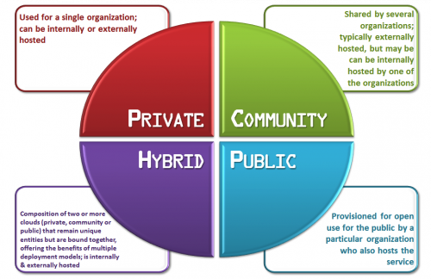

Figure 4.5: Types of cloud environment available.

**Cloud service models available in fig 7:**

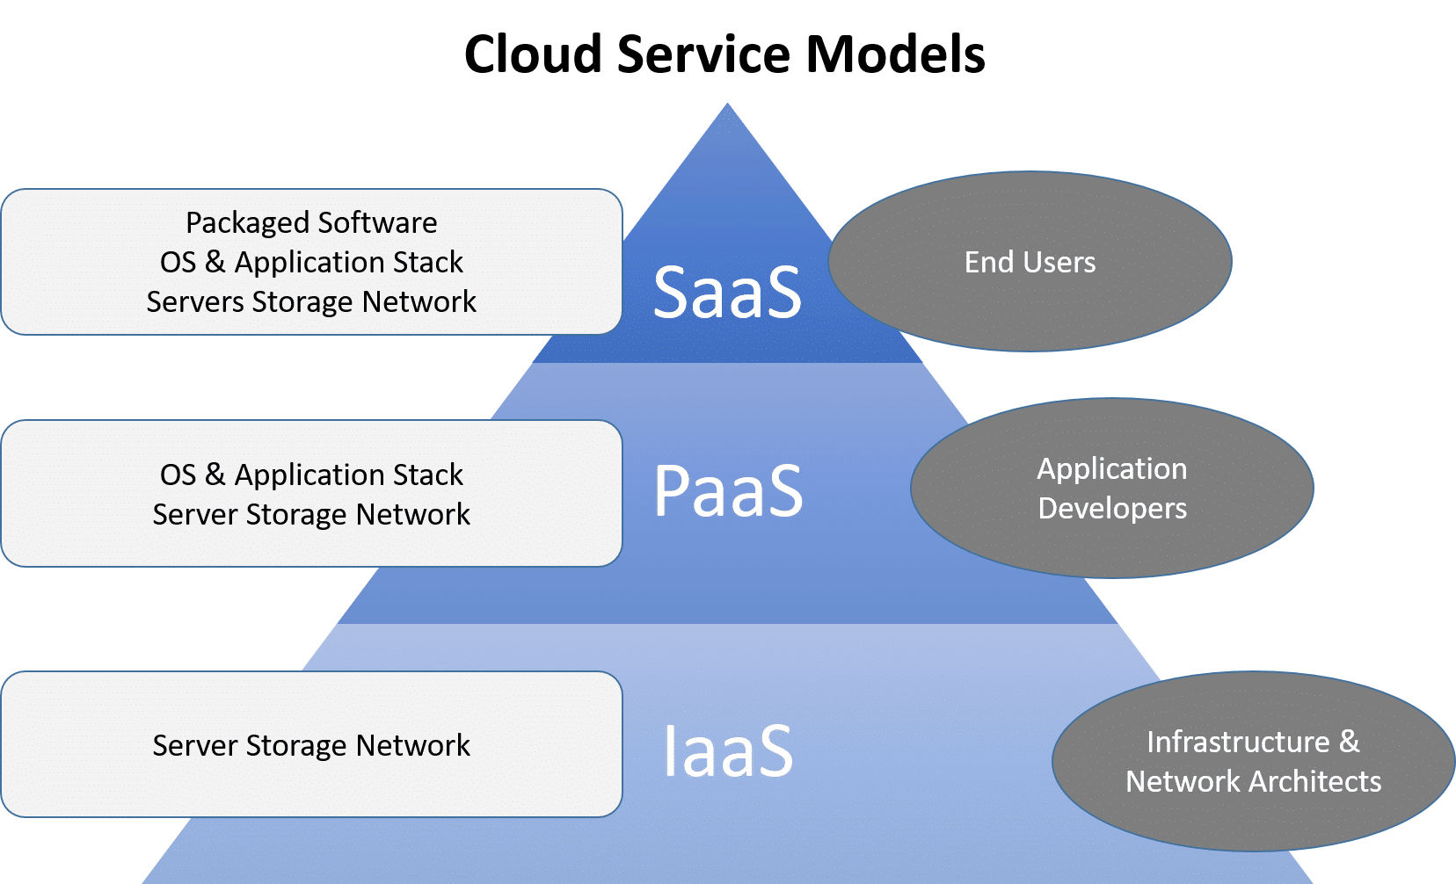

Figure 4.5: service models available.

Chapter 5

UML Diagrams

The Uni ed Modeling Language is a standard visual modeling language intended to be used for modeling business and similar processes,analysis,design, and implementa- tion of software-based systems.

Goals of UML

There are a number of goals for developing UML but the most important is to de ne some general purpose modeling language which all modelers can use and also it needs to be made simple to understand and use. UML diagrams are not only made for developers but also for business users, common people and anybody interested to understand the system. The system can be a software or non software. So it must be clear that UML is not a development method rather it accompanies with processes to make a successful.

At the conclusion the goal of UML can be de ned as a simple modeling mechanism to model all possible practical systems in today's complex environment. UML diagrams are the ultimate output of the entire discussion. All the elements, relationships are used to make a complete UML diagram and the diagram represents a system

Usecase Diagram

A use case diagram at its simplest is a representation of a user's interaction with the system that shows the relationship between the user and the di erent use cases in which the user is involved.

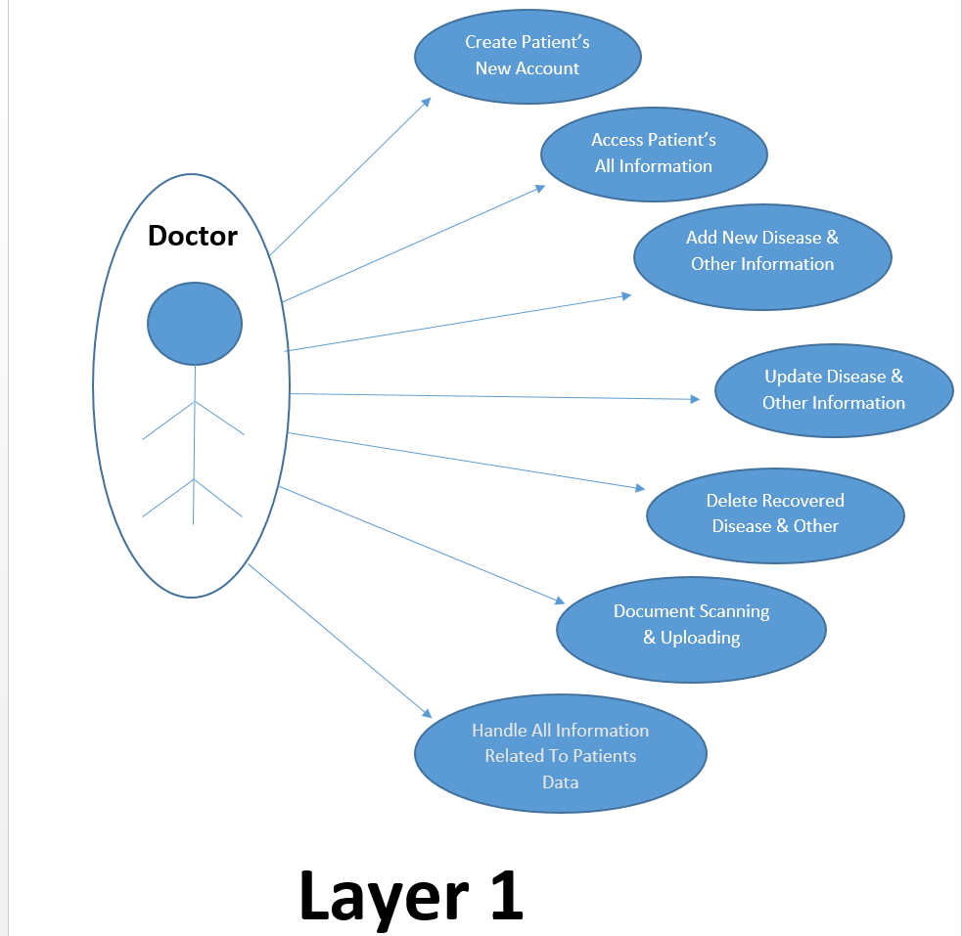

Figure 5.1: System Usecase Diagram

In System Usecase Diagram user (Doctor) will perform all the operation on patient’s data.

Doctor will able to create account of new patient, and add details of patient. Along with this

Doctor can add new disease, delete disease and update other details of patient on basic of current Situation of patient.

Activity Diagram

An activity diagram illustrates one individual activity. In our context, an activity represents a business process. Fundamental elements of the activity are actions and control elements (decision, division, merge, initiation, end, etc.).

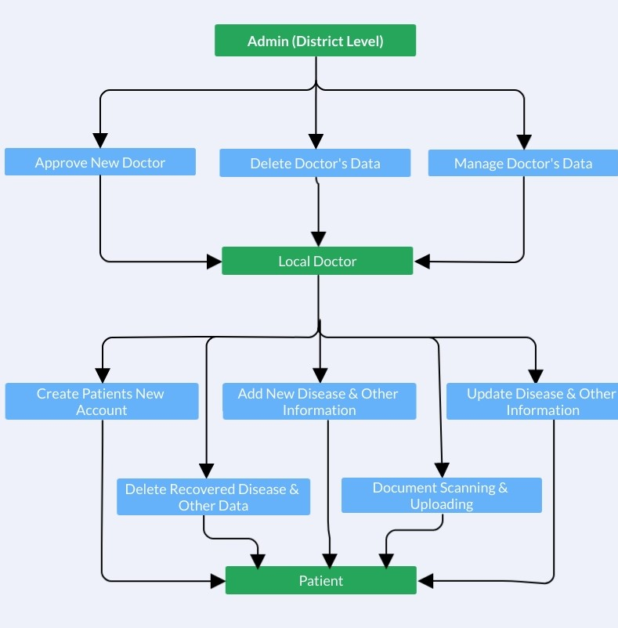

Figure 5.2: Activity Diagram

Activity diagram includes all types of ows like sequential,concurrent or branched

with decisions. It is nothing but preview of system execution or how system will execute once project will complete.

Sequence Diagrams:

* A sequence diagram is an interaction diagram. From the name it is clear that the diagram deals with some sequences, which are the sequence of messages owing from one object to another.
* Interaction among the components of a system is very important from implemen- tation and execution perspective. So Sequence diagram is used to visualize the sequence of calls in a system to perform a specfic functionality.

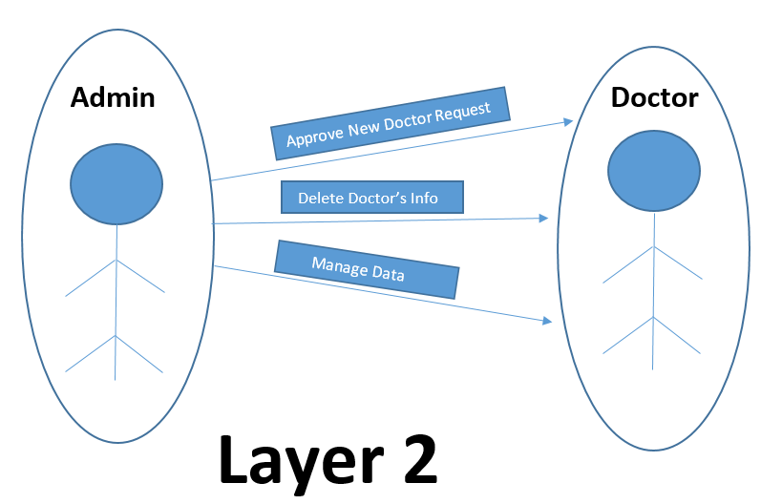

Figure 5.3: System Sequence Diagram

In above System Sequence Diagram messages, written with horizontal arrows with the

message name written above them, display interaction. Here important characteristic of a sequence diagram is that time passes from top to bottom : the interaction starts near the top ofthe diagram and ends at the bottom (i.e. Lower equals Later).

Chapter 6

System Requirements

Hardware Requirements

* Intel core i3 or greater
* 1Gb RAM or greater
* 60 GB Hard Disk

Software Requirements

* Windows 10 OS
* MongoDB
* XAMPP,Robo 3T

Mr. Sourabh Patil

Ms. Sahil Pathan

Mr. Vaibhav Chavan

Mr. Ajay Shete Prof. N. M. Sawant

(Students) (Project guide)

Prof. N. M. Sawant

(Head of Dept.)

Computer Science & Engg.,

SKN Sinhgad College of Engg., Korti.

# References

|  |  |
| --- | --- |
| 1] | Dasgupta, R., Qadeer, I., et al. **The national rural health mission (nrhm):** a critical overview. Indian J Public Health2005;49(3):138–40. |
| 2] | Srinivasa, D., Siddegowda, Y., et al. **Rural health care towards a healthy rural india: A social work response**.Asian Journal of DevelopmentMatters2018;12(1s):68–74. |
| 3] | Singh, P., Kathuria, R.. Infrastructure **and connectivity in india:** getting the basics right.Asian Economic Policy Review2016;11(2):266–285. |
| 4] | Fraser, H., Biondich, P., Moodley, D., Choi, S., Mamlin, B., Szolovits, P.. **Implementing electronic medical record systems in developingcountries.**Journal of Innovation in Health Informatics2005;13(2):83–95. |
| 5] | Pooja, B., Pai, M.M., Radhika, M.P.. **A dual cloud based secure environmental parameter monitoring system:** A wsn approac. In:InternationalConference on Cloud Computing. Springer; 2013, p. 189–198. |
| 6] | Freet, D., Agrawal, R., Walker, J.J., Badr, Y.. **Open source cloud management platforms and hypervisor technologies:** A review andcomparison. In:SoutheastCon, 2016. IEEE; 2016, p. 1-8. |
| 7] | Kasthurirathne S.N., Mamlin B., Kumara H., Grieve G., Biondich P.**Enabling better interoperability for healthcare: lessons in developing a standards based application programing interface for electronic medical record systems** Journal of medical systems, 39 (11) (2015), p. 182 |
| 8] | Nurmi D., Wolski R., Grzegorczyk C., Obertelli G., Soman S., Youseff L., *et al.***The eucalyptus open-source cloud-computing system** Cluster Computing and the Grid, IEEE (2009), pp. 124-131  CCGRID’09. 9th IEEE/ACM International Symposium on. 2009 |
| 9] | Latif R., Abbas H., Assar S., Ali Q.**Cloud computing risk assessment: a systematic literature review** Future Information Technology, Springer (2014), pp. 285-295 |